Lab 9: Point Coordinates

You’re going to create a program to store points in a coordinate system. This will be a simple X, Y coordinate plane. (0, 0) would be the origin. A coordinate will be stored in a class:

Your *Coordinate* class will have the following integer member variables:

* x: representing the X or horizontal component
* y: representing the Y or vertical component
* color: representing the console color (Windows only)

Your *Coordinate* class should have the following member functions:

* set: initialize the coordinates. Three input parameters mapped to X and Y and color.
* getX: returns the value of X
* getY: returns the value of Y
* move: move point horizontally by the first parameter units, and vertically by the second parameter units
* rotate: rotate the point 90 degrees counter-clockwise. Set X to –Y and Y to X.
* display: show the current values of the point in the format **(x, y) located in quadrant IV.** It will set the color of the text to be display prior to cout command. Use this command:

SetConsoleTextAttribute(GetStdHandle(STD_OUTPUT_HANDLE), 13);

The following numbers can be used to alter the font color:

0 Black 8 Grey  
1 Blue 9 Light Blue  
2 Green 10 Light Green  
3 Aqua 11 Light Aqua  
4 Dark Red 12 Bright Red  
5 Purple 13 Pink  
6 Muddy Yellow 14 Bright Yellow  
7 White (normal font color) 15 Bright White

This function needs to use x and y values to determine which quadrant the point lies in as listed in the figure:

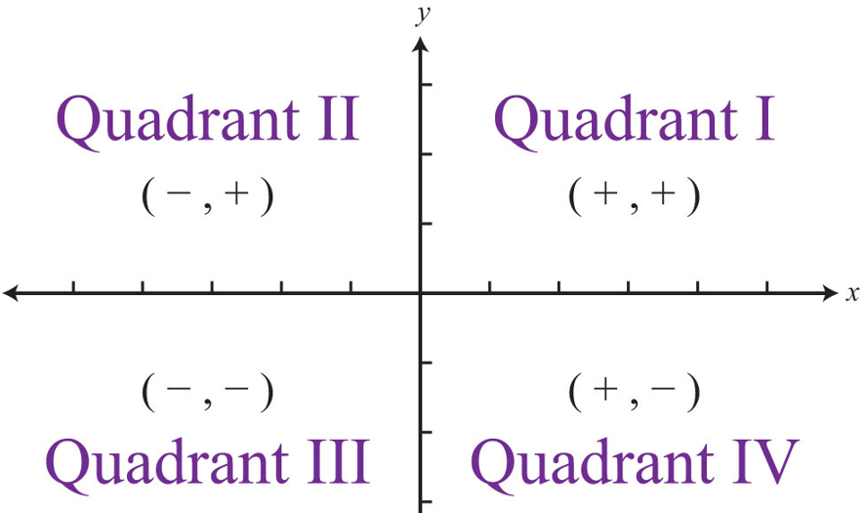

Make sure to #include <windows.h> for colors. Your *main()* program should define three coordinates A, B, and C. Then your program should then implement:

* Rotate A 360 degrees. Repeating call the rotate method. Display the updated point after each rotation.
* Increment B one position to the right and up.
* Move C back to the origin (0, 0). So just offset the X and Y coordinate in the opposite direction. Example, (5, -4) would be moved by (-5, 4) resulting in new position (0, 0).
* Write a function to calculate the slope of two points. This function will NOT be part of the class. This function should receive two coordinate objects as input. It should return the slope based on this formula

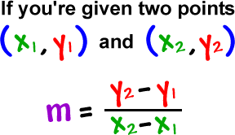

Here is an example output:

Rotating A:

(1, 2) is in quadrant I(-2, 1) is in quadrant II(-1, -2) is in quadrant III(2, -1) is in quadrant IV(1, 2) is in quadrant IIncrementing B:

(2, 3) is in quadrant I(3, 4) is in quadrant IMove C to origin:

(5, -4) is in quadrant IV(0, 0)

Slope of A to B = 1